Assignment 3 – Output

Nadzirah binti Mokhtar (282051)

**HOME**

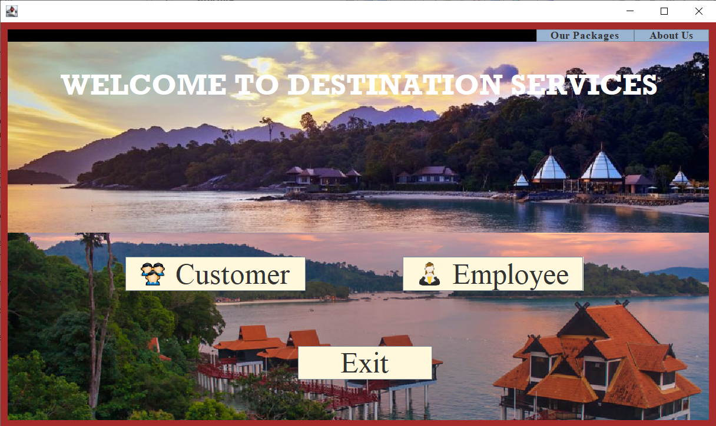

**LOGIN**

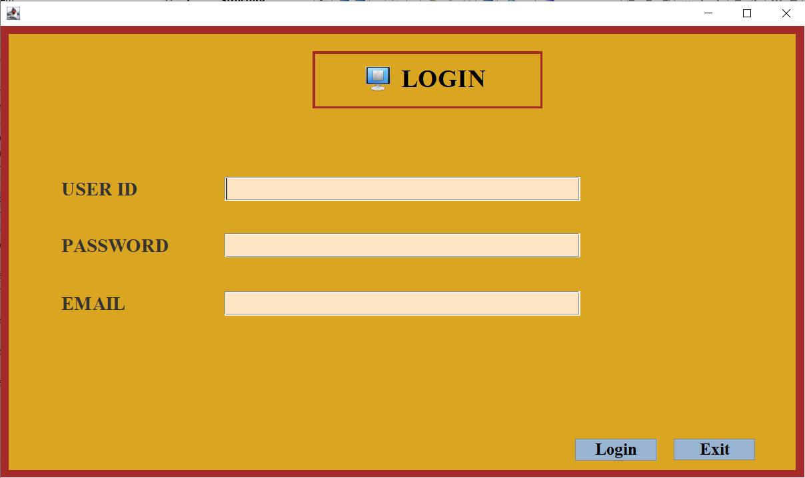

**COMPANY**

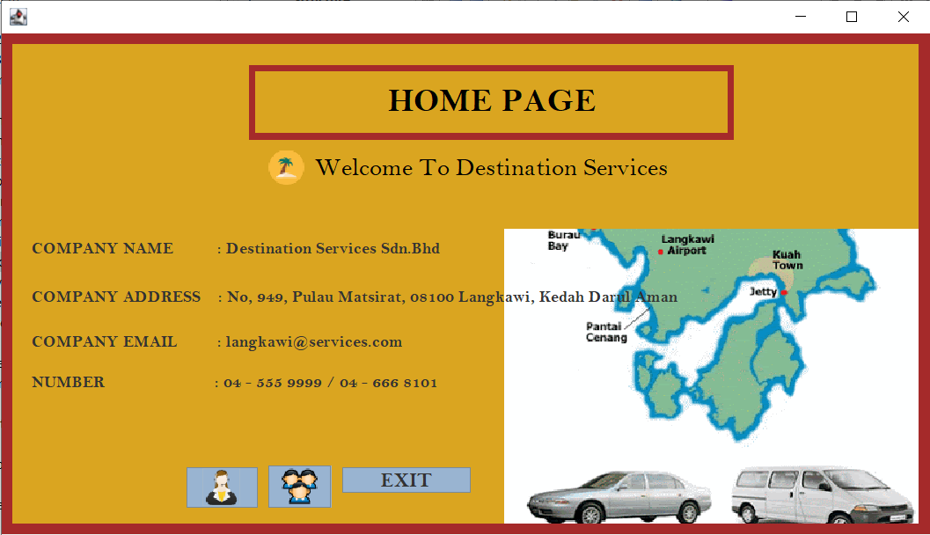

**CUSTOMER REGISTRATION**

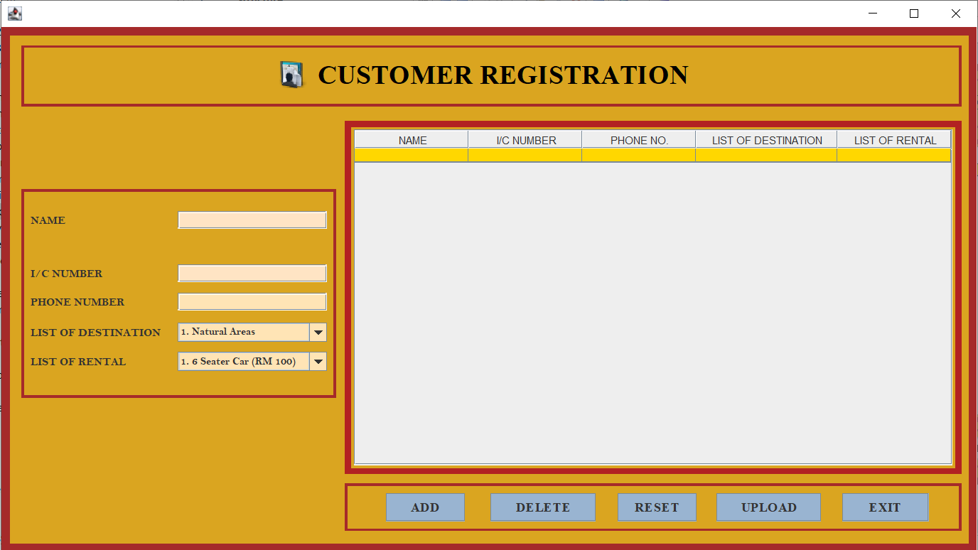

**EMPLOYEE MANAGE**

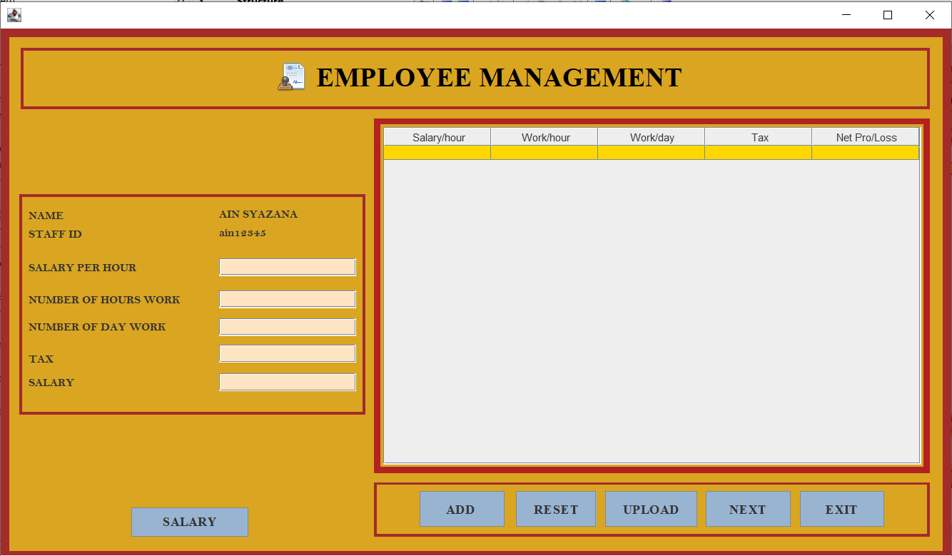

**FINANCE MANAGE**

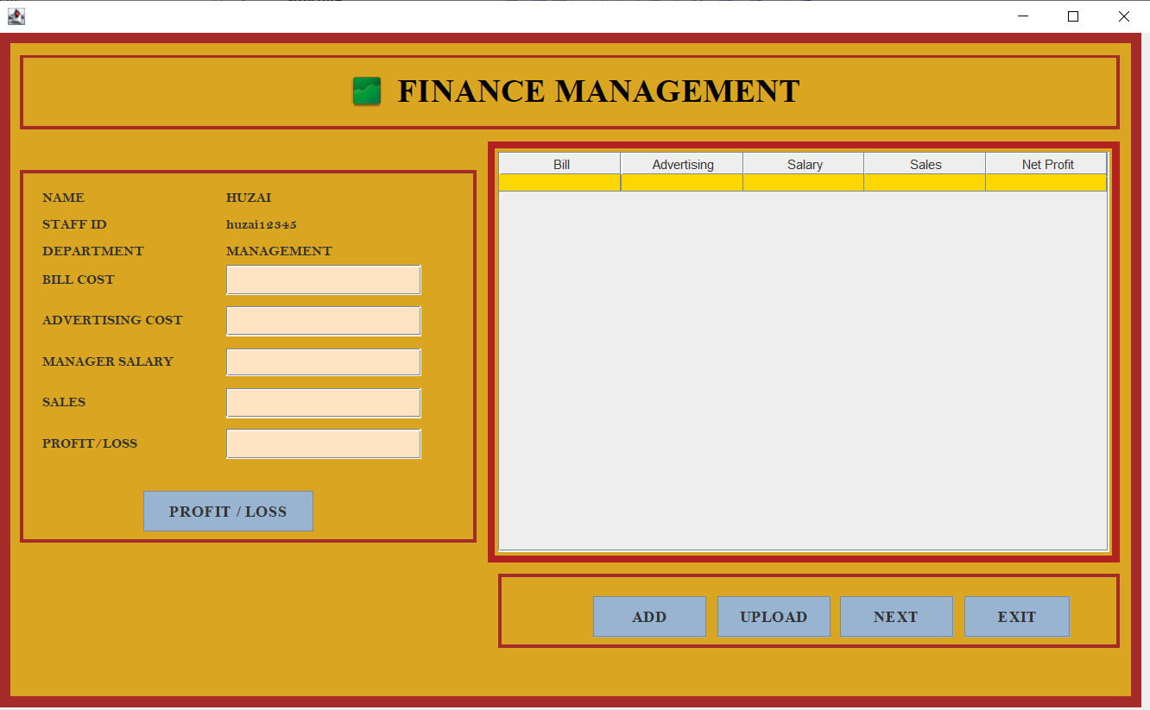

**PACKAGES**

